How to configure Gmail and install workprofile for android devices

Author:Saran M

Document Control
Version No. | Date | Status | Owner | Reason for Change
01 | 17/02/2022 | Draft | Saran M
02 |  | Approver | Vinay BL

Introduction 1
Configuring Gmail account using work profile 1
Installing Android Device policy 5
Please install Android Device Policy 5

Introduction
A work profile can be set up on an Android device to separate work apps and data from personal apps and data. With a work profile you can securely and privately use the same device for work and personal purposes—your organization manages your work apps and data while your personal apps, data, and usage remain private

Configuring Gmail account using work profile

Only Latest Android devices will support Work Profile
Non Supported models : Oppo,Vivo,Huawei,Redmi
Supported OS :

How to configure Gmail and install Work Profile on Android Device
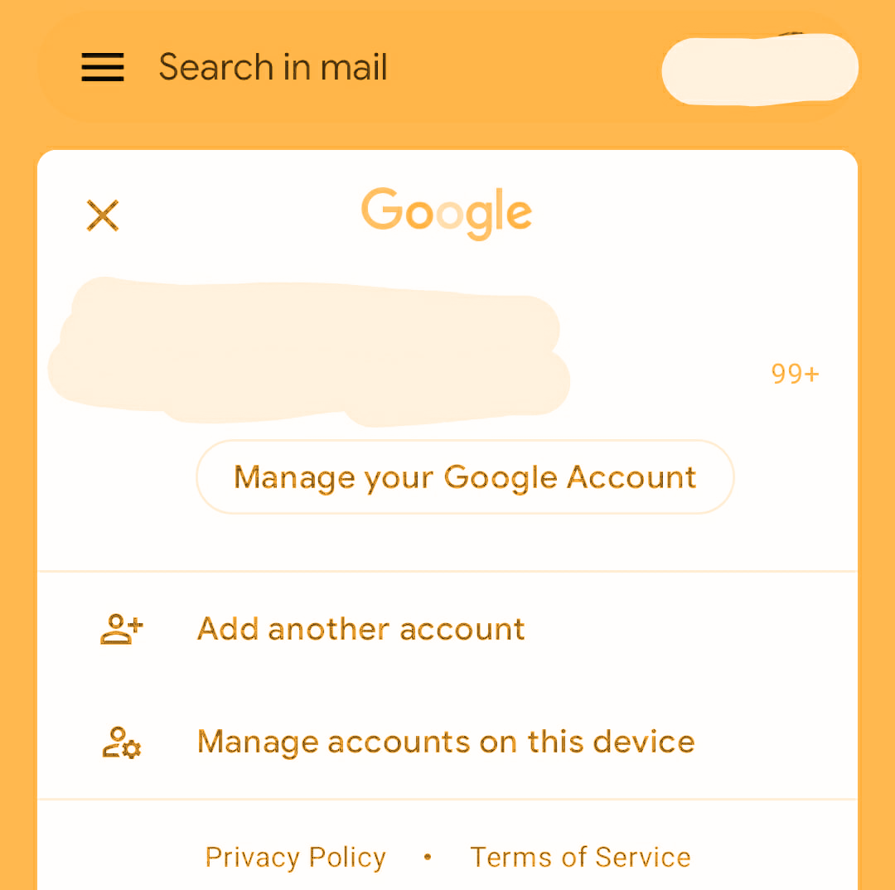

- Open your Gmail Application and click on account

- Select Add another account

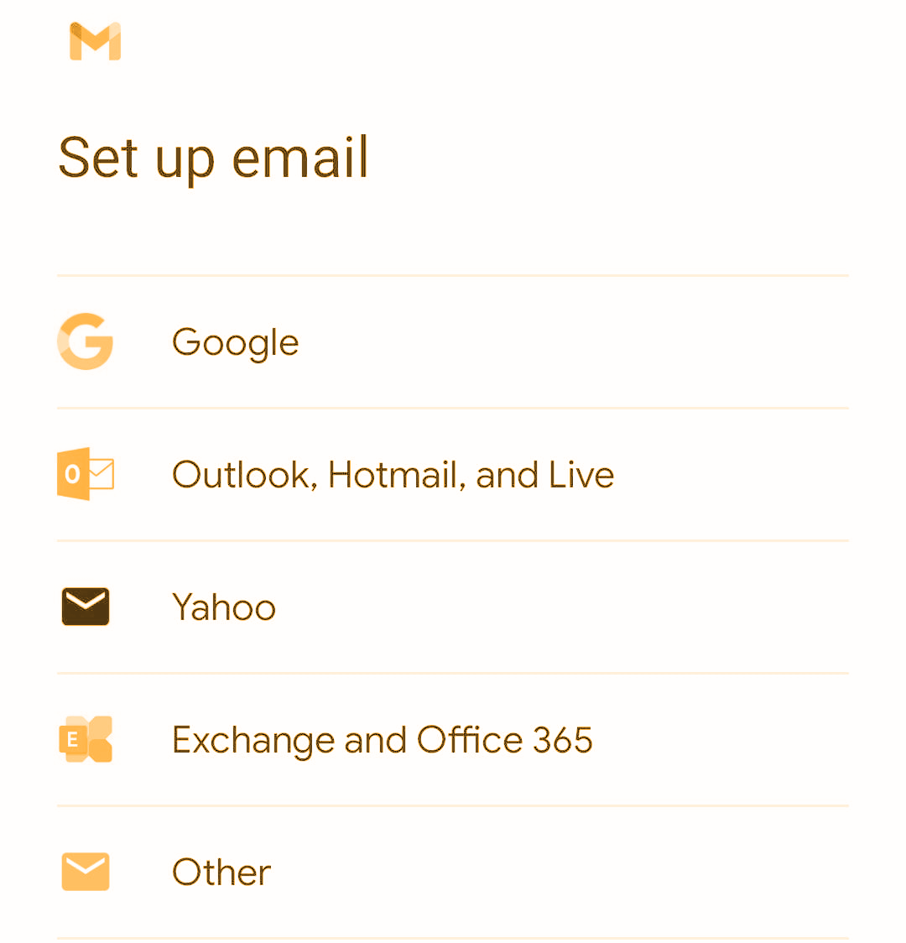

- Select Goole and click next

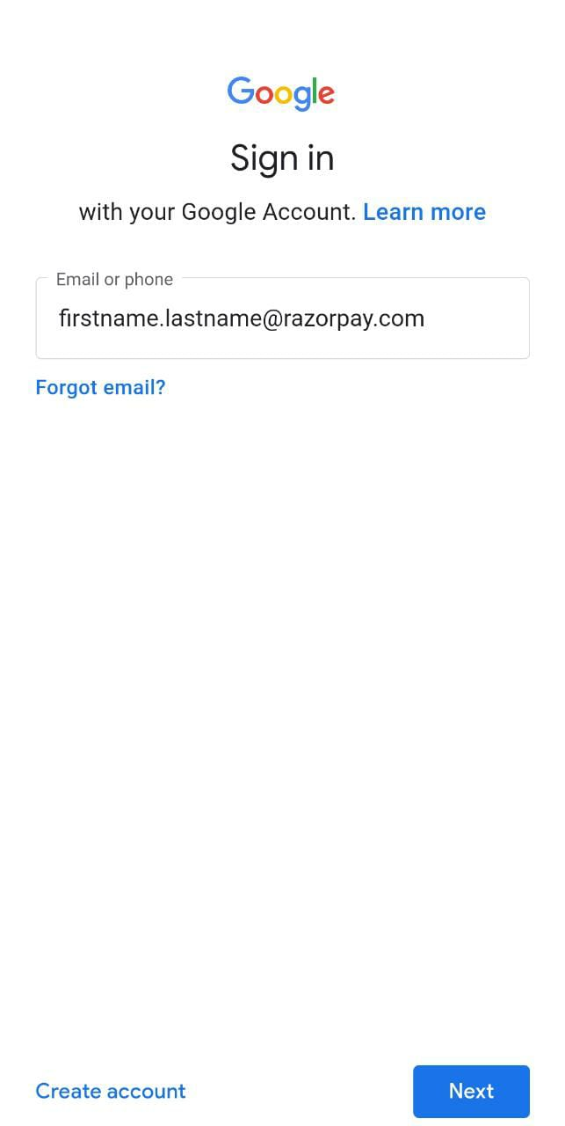

- Enter you Razorpay email address and click next

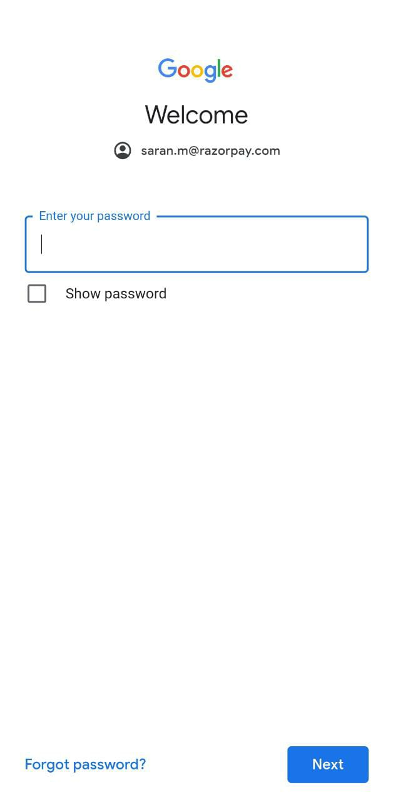

- Enter your password and click next

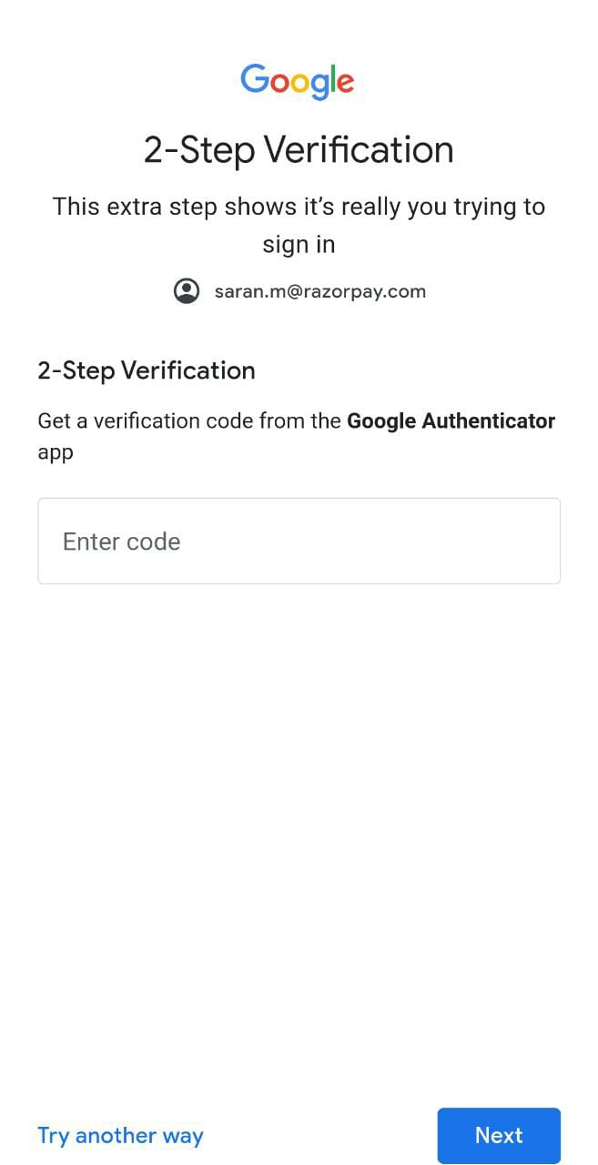

- Complete the 2-step verification process

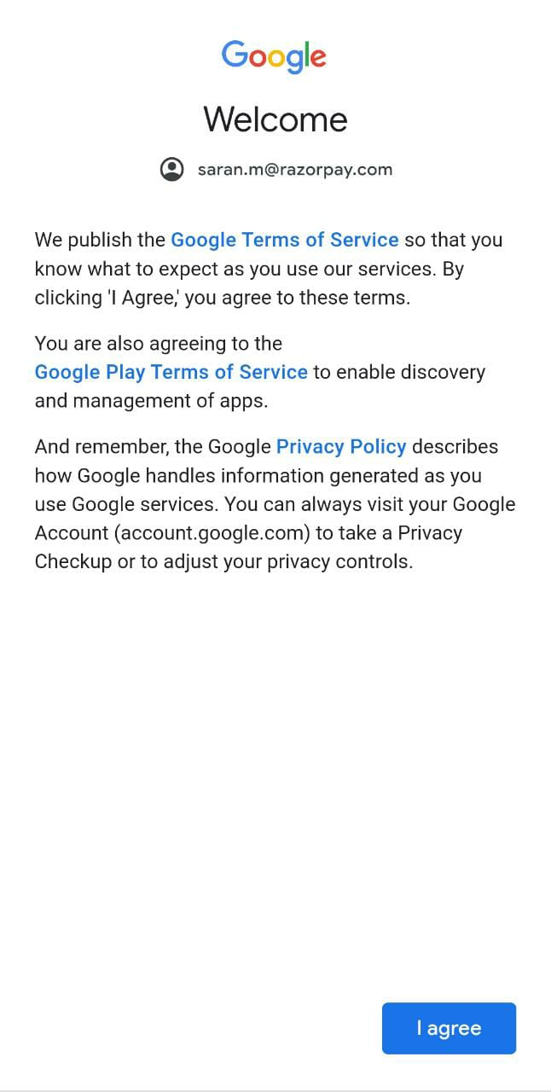

- Please Agree the terms and conditions

Installing Android Device policy
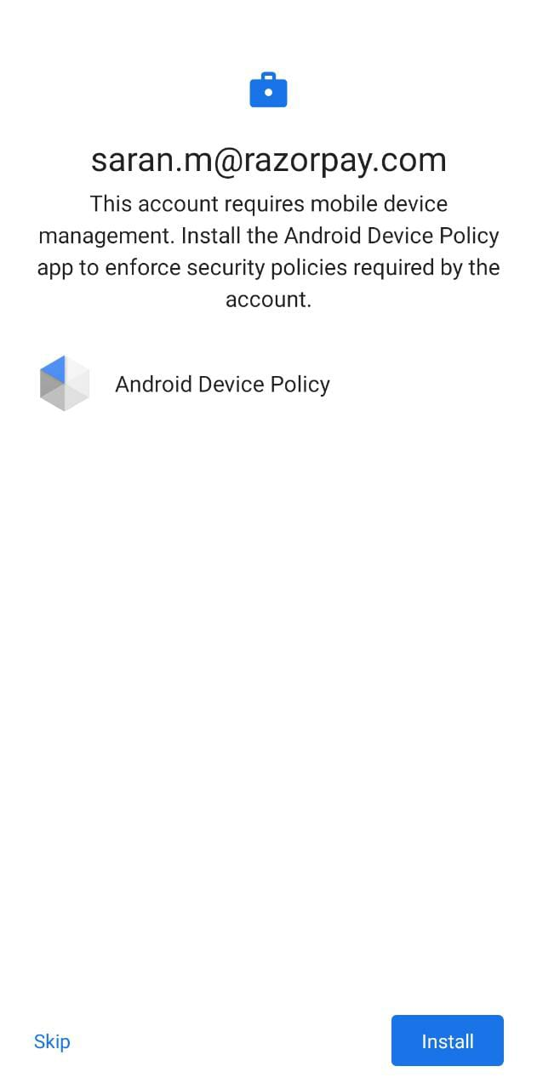

Please install Android Device Policy

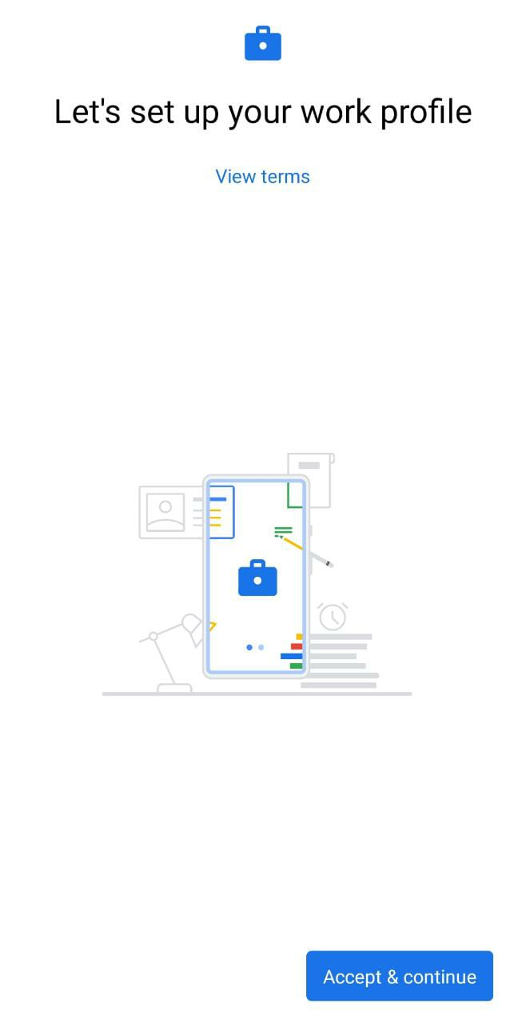

- Please click Accept Continue

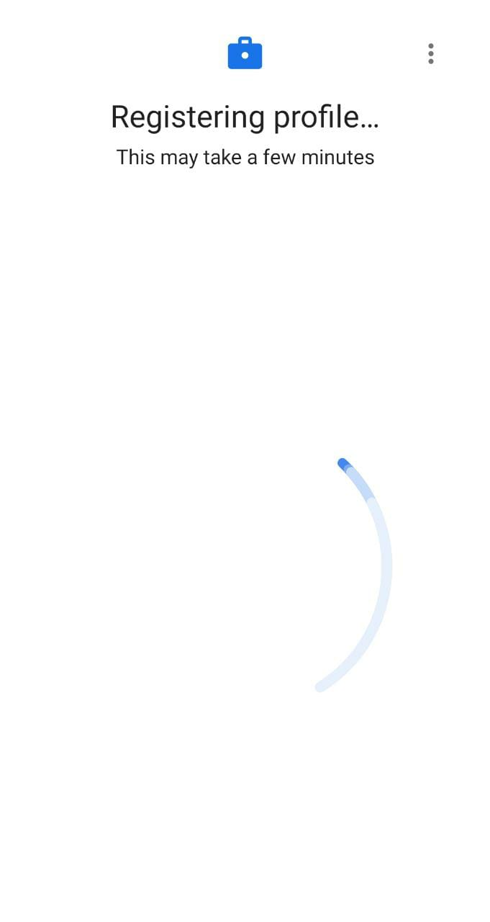

- Please wait for the Profile registration

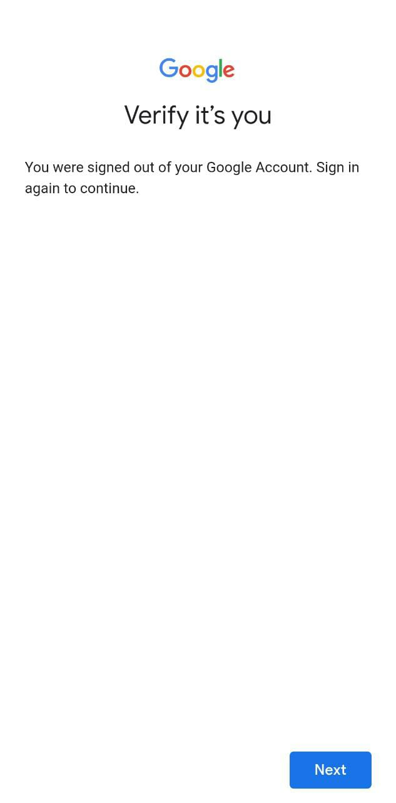

- Verify your account by entering the password

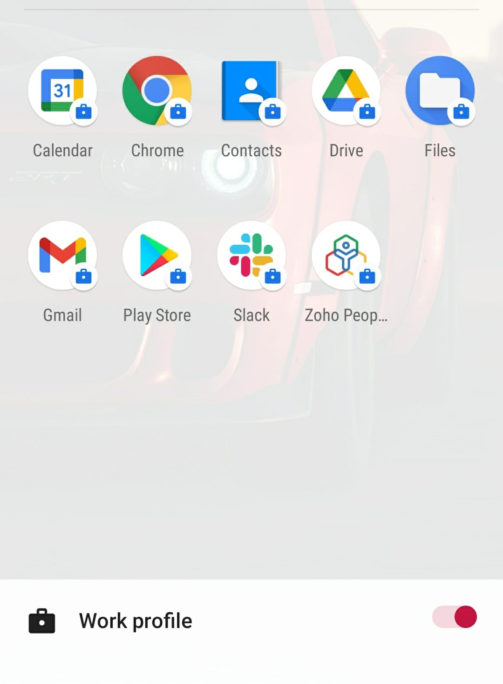
- Work profile configuration is completed and after the account verification you will see the work profile and personal profile as separate options.

Note: Any further assistance is required kindly feel free to write us on It-Team@razorpay.com
We are also reachable on the #tech_it slack channel.

----------------------------------------> End of Document < ------------------------------------

